Abstract— Internet of Things (IoT) expansion led the market to find alternative communication technologies since existing protocols are insufficient in terms of coverage, energy consumption to fit IoT needs. Low Power Wide Area Networks (LPWAN) emerged as an alternative cost-effective communication technology for the IoT market. LoRaWAN is an open LPWAN standard developed by LoRa Alliance and has key features i.e., low energy consumption, long-range communication, builtin security, GPS-free positioning. In this paper, we will introduce LoRaWAN technology, the state of art studies in the literature and provide open opportunities.
ESP8266 BASED PAXCOUNTER USING LoRaWAN TECHNOLOGY
ALAPARTHI SAI NAVEEN, ANURAG CHATURVEDI, YELAMANCHILI RAVIKANTH and Dr.Arun M.

INTRODUCTION
Cost-effective Internet connectivity is an essential issue for the low power embedded devices that are dedicated to a specific task. Conventional wireless communication technologies are insufficient when considered for coverage (communication range), energy consumption and cost. LPWAN aims to solve these problems which can scale and suitable for large-scale deployments for low power end devices. Low Power Wide Area Networks are supposed to operate at low data rates to have kilometer range coverage from dense urban to suburban regions. LoRaWAN, SigFox, NB-IoT, Weightless, and other sub-GHz communication technologies are successfully providing these functionalities, however, LoRaWAN took the attention of organizations, communities, and researchers and have become a popular LPWAN technology.
LPWANs have some common characteristic that distinguishes these technologies within traditional communication networks:
- Low power, the network and end devices should consume low energy.
- Communication, deployment and management cost is an essential issue since a large number of deployments are considered.
- From devices to the applications, the whole eco-system needs strong security mechanism.
- Built-in localization is a plus when indoor deployments are considered.
- Network deployment in dense urban areas leads radio networks to jam within same or adjacent channels. Robust (interference resistance) modulation is a must.
- End of the day, nodes generate data and this has to be handled properly.

Architecture
Network topology of the LoRaWAN is considered as star-of-stars and from the architectural point of view, the system has three main components
i.network servers,ii.gateways and iii.end nodes.
End nodes communicate with the network server (or data server) via GWs and Node-to-GW communication can be either LoRa or FSK modulation with different data rates and channels. Network servers manage the GWs through standard IP technology and data frames sent through end nodes, received by GWs and routed through the network server. An overview of the LoRaWAN architecture is presented in Figure
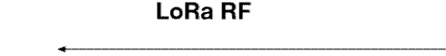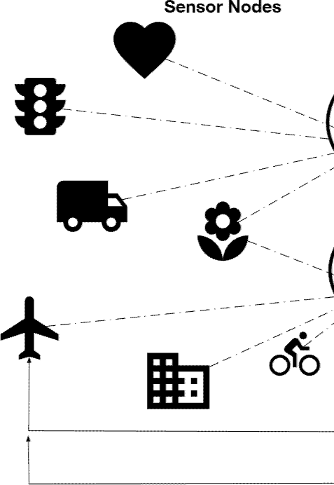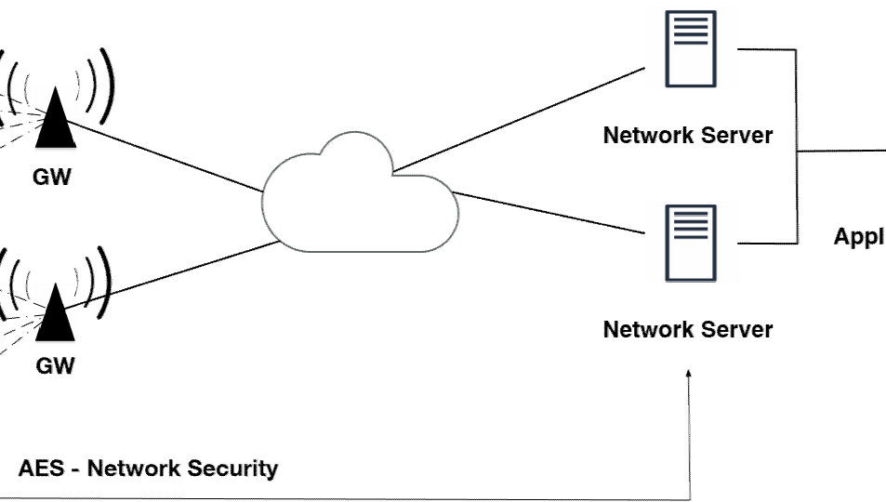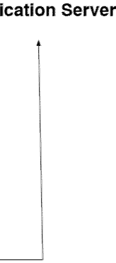

III.PROTOCOL
OSI Reference Layers
Layered network design provides seamless communication among different network elements. LoRaWAN layers can be mapped to OSI Reference for better understanding underlying technology as presented in Figure. Generic LoRaWAN network deployments consist of multiple end-nodes, one or more gateways and at least one network server to run a complete network. LoRaWAN networks are distinguished with classical TCP/IP communication with GWs and end-nodes. Network servers are plain application services that operate over Transport Layer however, all MAC layer functionalities of the whole network are controlled by the Network Server.

Physical Layer-LoRa
Long Range (LoRa) is a physical layer technology introduced by Semtech and intellectual property rights of the modulation are held by the company.
LoRa modulation extends the traditional Spread Spectrum principles to reduce the amount of energy required to transmit bits over the channel. The Data Rate (DR) in attainable communication can be computed from the bandwidth BW (Hz), the Spreading Factor (SF), and the Coding Rate (CR).
The LoRa modulation has better performance than Frequency Hopping techniques in managing interferences. The modulation can tolerate interferences of arbitrary power levels up to 30% of the symbol length with less than 6 dB sensitivity degradation.
SF is the key variable that ensures the quality of service. When using the lower range of SF values, the data rate is very high and air time is low. The higher SFs extend the range but limit the Quality of Service. SFs from 7 to 12 allow orthogonal communications, i.e., different networks can speak simultaneously on the same frequency band without interfering. Table presents SF values against Chirps/Symbol and Demodulation SNR. SF LoRa modulation is based on the representation of each bit of information by multi-chirps information

Factor |  | SNR
7 | 128 | −7.5 dB
8 | 256 | −10 dB
9 | 512 | −12.5 dB
10 | 1024 | −15 dB
11 | 2048 | −17.5 dB
12 | 4096 | −20 dB

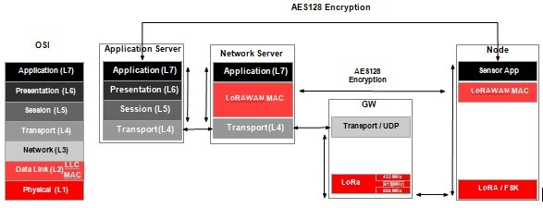

MAC Layer—LoRaWAN
LoRaWAN is a layer two protocol to provide LoRa end devices Adaptive Data Rate (ADR), Security, GPS-free Geolocation, Channel Access and Energy Saving functionalities. LoRaWAN is introduced by LoRa alliance. By version 1.1 LoRaWAN supports roaming and adds additional security features to Class B.
LoRa and other narrowband technologies have to be efficient that’s any overhead will cost more energy or latency. To overcome this problem LoRaWAN uses a quite simple channel management strategy to keep end devices to be cost-effective. LoRaWAN adopts pure Aloha with additional ACK mechanisms to simplify medium access control. MAC layer protocol defines one mandatory and two optional classes for different possible use cases.

Energy
LPWANs built on the communication range and energy efficiency, this has been investigated among other narrowband technologies. LoRaWAN Class A devices are designed to be the most energy efficient modes of the protocol. Since DL procedure is initiated by successful UL transmissions, end-nodes don’t require power during sleep mode for network operations. Class A devices intended to send a few packets (i.e., 3 packets per day), LoRa transceivers are not active frequently. Despite efficient protocol design, energy consumption highly depended on the hardware implementations.
Semtech SX1272/76 transceivers are the first market-ready chips that have been actively used LoRa end-node manufacturers. According to the datasheets, SX1276 has 100 mW constant RF output at +20 dBm and can have high sensitivity down to −148 dBm.
Class | Battery  Consumption | Description
A | Most energy efficient | Must be supported by all the End-  Nodes. DL after TX
B | Efficient  with controlled DL | Slotted communication  synchronized with  beacon frames
C | Least efficient | Devices listen  continuously.  DL without latency.

Security
LoRaWAN has built-in security to protect network protocol and user data. Data through node-to-application and note-to-network-server are protected by AES 128 encryption by four components:
- DevAddr: a 32 bit device identifier.
- AppEUI: an Application unique identifier which as IEEE UI64 address space.
- NwkSKey: a Network session key used to encrypt end-device to network-server communication.
- AppSKey: an Application session key (AES-128 key) used to protect application specific data.
LoRaWAN supports two main end-device activation methods (i) Over-the-Air Activation (OTAA) and (ii) Activation by Personalization (ABP).

Over-the-Air Activation (OTAA)
End-devices require to join the network before the application specific data transmission stage.
End nodes initiate the activation process with an unencrypted Join Request, with AppEUI (8 octets), DevUI(8 octets) and a DevNonce (2 octets). DevNonce is a randomly generated and GW keeps tracks of these values for each end-node.
If the network server replies to the Join Request with a Join Accept, end-node is allowed to join the network. Unanswered messages yield that end-node cannot participate in the network.
Join Accept message contains; a random AppNonce (3 octets), Network Identifier—NetID (3 octets), an end-node address—DevAddr (4 octets), a delay RxDelay between TX and RX(1 octet), DL configuration parameters DLSettings (1 octet) and optional channel frequency list CFList.
Initial Join Request message sent from a node is unencrypted, however, the response message from Network Server (Join Accept message) is encrypted with AppKey. NwkSKey and AppSKey are calculated as follows:
NwkSKey= ases128_encrypt(AppKey,0x01|AppNonce|NetID|DevNonce|pad₁₆)
AppSKey= ases128_encrypt(AppKey,0x02|AppNonce|NetID|DevNonc

Activation by Personalization (ABP)
In ABP mode, end-devices store DevAddr, NwkSKey, and AppSKey to eliminate Join Request/Join Response stages. These devices can directly communicate with the Network server with given keys. Storing and securing critical keys is a vital task, any hardware attack can compromise these keys and unwanted network access may occur. Also, ABP strictly binds endnodes to the specific Network Server where these types of devices cannot benefit roaming features available since LoRaWAN v1.1.

SCANNING OF MAC ADDRESSES
The Paxcounter code stores scanned MAC addresses in the device’s RAM, and keeps it in RAM temporary for a configurable scan cycle time (2 seconds). After each scan cycle the collected MAC data is erased from RAM. MAC data never is transferred to the LoRaWAN network. No kind of tracking and no persistent storing of MAC data or timestamps on the device and no other kind of analytics than counting is implemented in this code. Wireless networks are not touched by this code, but MAC addresses from wireless devices as well within as not within wireless networks, regardless if encrypted or unencrypted, are made visible and scanned by this code. The same applies to Bluetooth MACs, if the bluetooth option in the code is enabled.”

Automatic Beacon Monitoring is the key to scan the Wi-Fi MAC addresses and Wi-Fi Hotspots as stated above that the latest android versions allow and send continuous wi-fi signals in search of a Wi-Fi beacon. Thus, enabling us to correctly count the passengers.

DIFFERENT TYPES OF PAXCOUNTERS:
- DynaPCN 10-20 Automatic Passenger Counter
- Infrared Sensor based Automatic Passenger Counter
- Millimeter Wave Sensor based Automatic Passenger Counter
- Electronic Registering Farebox based Passenger Counter
- Weight Sensor based Passenger Counter.

Table 1 COMPARISON
PARAMETERS | ESP8266 Sensor | Dyna PCN Sensor | mm Wave Sensor | Electronic Registering Farebox | Weight Sensor
Cost | Low | High | High | High | High(Require more number of sensors)
Installation | Easy | Difficult (More Wires) | Difficult | Easy | Difficult  (Disturbs the complete infrastructure)
Accuracy | High  (97-99%) | High  (95-99%) | High  (97-99%) | Medium  (70-85%) | Low  (50-60%)
Man Power | Low | Low | Low | High | Low
Security | High | High | High | Low | Low
Maintenance | Once in a year | Daily Cleaning | Daily Cleaning | Daily Cleaning | Once in a month

UNDERSTANDING THE PROBLEM
- The amount of people who use the common/public transport are in huge in number which can often lead to miscalculation/often recalculation for reassurance.

- Apart from the transport issue when people gather in auditorium/common area for a event/any purpose their count can always not be right.

- The amount of manpower used just for the counting and reassurance for the right count of people in just VIT is evidently high.

IMPLEMENTATION (IN VIT VELLORE)
So we assembled a device which can tackle the issues mentioned above.

The Low power high range of LoRa technology helps in covering the whole campus with a single chip and the small baud rate on the ESP8266.

LoRa board helps in small amount of data collection and faster processing of the passenger count.

The applications of this device cannot be limited to just Shuttle Cabs. It can be used in Conference Rooms, Events, Gatherings and Auditoriums etc.

As the deployment ensues in our college thus the target audience is going to be students and the main deployment shall be in shuttle cabs.

HARDWARE AND SOFTWARE SPECIFICATIONS

HARDWARE SPECIFICATIONS
This project consists of very less hardware components which are enlisted:
- ESP8266
- Module RFM 95 (Hoperf Electronics)
- GPS MODULE
- LED BOARD
ESP8266
The ESP8266 is a low-cost Wi-Fi microchip, with a full TCP/IP stack and microcontroller capability, produced by Espressif Systems in Shanghai, China.
Devices that connect to Wi-Fi networks are called stations (STA). Connection to Wi-Fi is provided by an access point (AP), that acts as a hub for one or more stations. The access point on the other end is connected to a wired network. An access point is usually integrated with a router to provide access from a Wi-Fi network to the internet. Each access point is recognized by a SSID (Service Set Identifier), that essentially is the name of network you select when connecting a device (station) to the Wi-Fi.

ESP8266 modules can operate as a station, so we can connect it to the Wi-Fi network. It can also operate as a soft access point (soft-AP), to establish its own Wi-Fi network. When the ESP8266 module is operating as a soft access point, we can connect other stations to the ESP module. ESP8266 is also able to operate as both a station and a soft access point mode. This provides the possibility of building e.g. mesh networks.

FEATURES
- Processor: L106 32-bit RISC microprocessor core based on the Tensilica Xtensa Diamond Standard 106 Micro running at 80 MHz
- Memory:
32 KB instruction RAM
32 KB instruction cache RAM
80 KB user-data RAM
16 KB ETS system-data RAM
External QSPI flash: up to 16 MB is supported (512 KB to 4 MB typically included)
- IEEE 802.11 b/g/n Wi-Fi
- Integrated TR switch, balun, LNA, power amplifier and matching network
- WEP or WPA/WPA2 authentication, or open networks
- 16 GPIO pins
- SPI
- I²C (software implementation)[6]
- I²S interfaces with DMA (sharing pins with GPIO)
- UART on dedicated pins, plus a transmit-only UART can be enabled on GPIO2
- 10-bit ADC (successive approximation ADC)

MODULE RFM95
The RFM95/96/97/98(W) transceivers feature the LoRa long range modem that provides ultra-long range spread spectrum communication and high interference immunity whilst minimizing current consumption. Using Hope RF’s patented LoRa modulation technique RFM95/96/97/98(W) can achieve a sensitivity of over - 148dBm using a low cost crystal and bill of materials. The high sensitivity combined with the integrated +20 dBm power amplifier yields industry leading link budget making it optimal for any application requiring range or robustness. LoRaTM also provides significant advantages in both blocking and selectivity over conventional modulation techniques, solving the traditional design compromise between range, interference immunity and energy consumption. These devices also support high performance (G)FSK modes for systems including WMBus, IEEE802.15.4g. The RFM95/96/97/98(W) deliver exceptional phase noise, selectivity, receiver linearity and IIP3 for significantly lower current consumption than competing devices.

FEATURES
- LoRa Modem.
- 168 dB maximum link budget.
- +20 dBm – 100 mW constant RF output vs. V supply.
- +14 dBm high efficiency PA.
- Programmable bit rate up to 300 kbps.
- High sensitivity: down to -148 dBm.
- Bullet-proof front end: IIP3 = -12.5 dBm.
- Excellent blocking immunity.
- Low RX current of 10.3 mA, 200 nA register retention.
- Fully integrated synthesizer with a resolution of 61 Hz.
- FSK, GFSK, MSK, GMSK, LoRa and OOK modulation.
- Built-in bit synchronizer for clock recovery.
- Preamble detection.
- 127 dB Dynamic Range RSSI.
- Automatic RF Sense and CAD with ultra-fast AFC.
- Packet engine up to 256 bytes with CRC.
- Built-in temperature sensor and low battery indicator.
- Module Size:16*16mm

GPS MODULE
Global Positioning System (GPS) is a satellite-based system that uses satellites and ground stations to measure and compute its position on Earth. GPS is also known as Navigation System with Time and Ranging (NAVSTAR) GPS.
GPS receiver needs to receive data from at least 4 satellites for accuracy purpose. GPS receiver does not transmit any information to the satellites. This GPS receiver is used in many applications like smart phones, Cabs, Fleet management etc.
GPS receiver uses a constellation of satellites and ground stations to calculate accurate location wherever it is located.
These GPS satellites transmit information signal over radio frequency (1.1 to 1.5 GHz) to the receiver. With the help of this received information, a ground station or GPS module can compute its position and time.
GPS receiver receives information signals from GPS satellites and calculates its distance from satellites. This is done by measuring the time required for the signal to travel from satellite to the receiver.

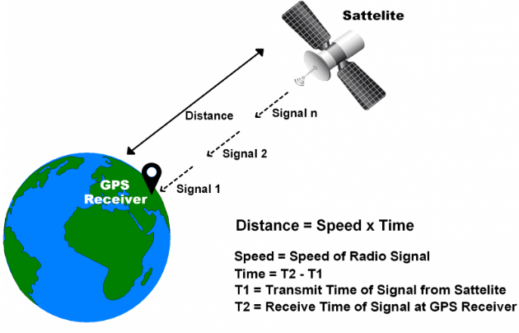

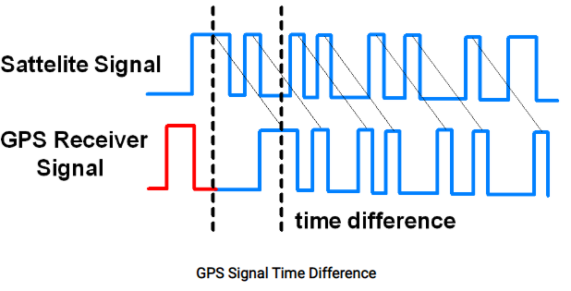
GPS receiver module gives output in standard (National Marine Electronics Association) NMEA string format. It provides output serially on Tx pin with default 9600 Baud rate.
This NMEA string output from GPS receiver contains different parameters separated by commas like longitude, latitude, altitude, time etc. Each string starts with ‘$’ and ends with carriage return/line feed sequence.

Table 2 GPS DECODER TABLE
Name | Example | Units | Description
Message ID | $GPGGA |  | GGA Protocol Header
UTC Time | 184241.000 |  | hhmmss.sss
Latitude | 1829.9639 |  | ddmm.mmmm
N/S Indicator | N |  | N=North, S=South
Longitude | 07347.6174 |  | dddmm.mmmm
E/W Indicator | E |  | E=East, W=West
Position Fix Indicator | 1 |  | Fix GPS SPS mode
Satellites Used | 05 |  | Range 0 to 12
HDOP | 2.1 |  | Horizontal Dilution of Precision
MSL Altitude | 607.1 | Meters | Mean Sea Level
Units | M | Meters
Geoid Separation | 64.7 | Meters
Units | M | Meters
Age of Diff. Corr. | - |  | Null field if DGPS is not used
Diff. Ref Station ID | 0000
Checksum | *7C
Carriage return Line Feed | <CR><LF> |  | End of message transmission

LED DISPLAY BOARD
Apart from displaying the passenger count and viewing it on the User Device, LED boards are used for a local audience, which ensures and helps in avoiding the confusion.
A LED display is a flat panel display that uses an array of light-emitting diodes as pixels for a video display. Their brightness allows them to be used outdoors where they are visible in the sun for store signs and billboards.

FREQUENCY ASSIGNMENT
The ISM bands in which our device works should be taken into account depending on our location “Country, Region or Continent” There are tables in which the national assignments of frequencies and use are indicated under the responsibility of the national authority.
The International Radio Regulations have divided the world into 3 regions to organize the radio spectrum.
- Region 1 comprises Europe, Africa, the former Soviet Union, Mongolia and the Middle East west of the Persian Gulf, including Iraq. The western boundary is defined by Line B.
- Region 2 covers the Americas, including Greenland, and some of the eastern Pacific islands. The eastern boundary is defined by Line B.
- Region 3 contains most of Asia not belonging to the former Soviet Union (FSU), east of Iran, including most of Oceania.

Table 3 DETAILED RANGES
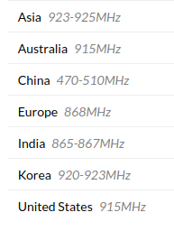
SOFTWARE SPECIFICATIONS
Before compiling the code:
- Desired hardware Target is selected.
- Duty cycle regulations are set.
- Frequency band is selected.

Uploading of Code
Initially, using USB/UART cable: To upload the code via cable to ESP8266 board this needs to be switched from run to bootloader mode.

The ESP8266 board was configured using arduino integrated development environment (IDE) and by using C++ programming language.

The passenger count can be seen on any device as the data collected is stored on a cloud, service given by MQTT.

The Arduino integrated development environment (IDE) is a cross-platform application (for Windows, macOS, and Linux) that is written in the programming language Java.

The ESP8266 has a Wi-Fi library that has been developed based on ESP8266 SDK, using the naming conventions and overall functionality philosophy of the Arduino WiFi library.
To hook up the ESP module to Wi-Fi (like hooking up a mobile phone to a hot spot)
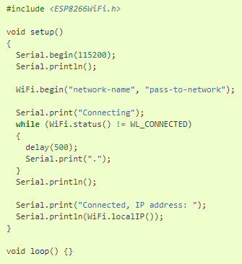
ESP8266 WIFI SCAN CLASS is called by using the scanNetworks() function. This results in scanning for available Wi-Fi networks in one run and return the number of networks that has been discovered.
There is also another important code line used to filter out the unnecessary SSIDs captured by the ESP8266 Wi-Fi beacon i.e the return of RSSI (Received Signal Strength Indication).
The devices closer to the beacon have a strong strength indication rather than the farther device. Thus, resulting in filtering out the unwanted devices and increasing the accuracy.

MQTT Box
MQTT stands for MQ Telemetry Transport. It is a publish/subscribe, extremely simple and lightweight messaging protocol, designed for constrained devices and low-bandwidth, high-latency or unreliable networks.
MQTTBox is a helper program to develop and load test MQTT based clients, brokers, devices, cloud and apps. Every aspect of MQTTBox is specifically designed to maximize development and testing productivity.
MQTT is a simple messaging protocol, designed for constrained devices with low-bandwidth. So, it's the perfect solution for Internet of Things applications. MQTT allows you to send commands to control outputs, read and publish data from sensor nodes and much more.

RESULTS
The board was developed for but not limited to monitor the real time passenger flow. The board comprises two different wireless communication modules namely, Long-range technology (LoRa) and WiFi (using ESP8266). The board can be configured to communicate either using LoRa or WiFi or both. The board has been tested and the wireless communication operates successfully.
A ESP8266 device along with the RFM 95 is integrated with a GPS module and placed in the shuttle cab. Each device placed has a unique identity. The placed device is synchronized with the LoRa WAN server present in the campus.
The device when switched on starts scanning for all the WiFi signals available in its range which are emitted from the User Device (Student’s Mobile Phone). The signals received are filtered out on the basis of the RSSI and accurate count of students present in the shuttle cab updated on the cloud and the LoRa server present in the campus too.
The GPS module gives out the exact location of the shuttle cab and the data collected is then presented to the students via a User Interface on their mobile phones.
The paxcounter device assembled by us was successful and was tested for a small audience of 8 people and the accuracy obtained was at 100% and was displayed on a LED display board.
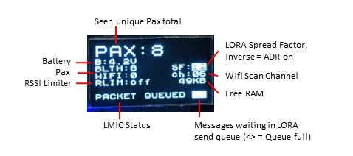

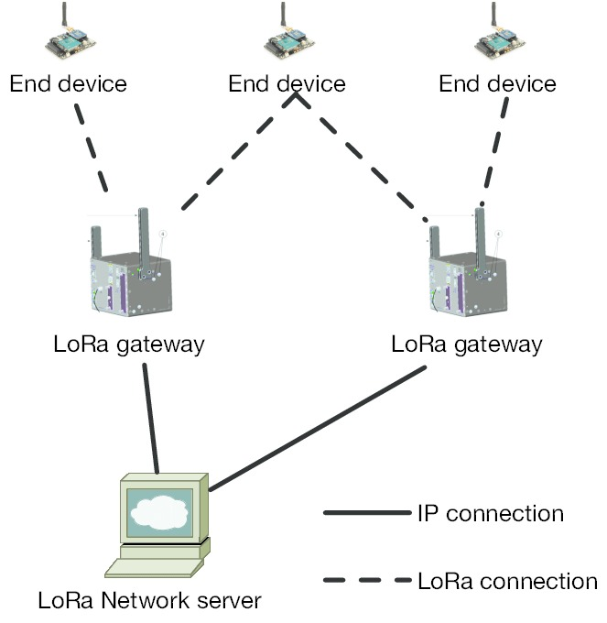
The device was Time Synced and was also integrated with a GPS Module and a RFM 95 Module for accessing LoRa network.
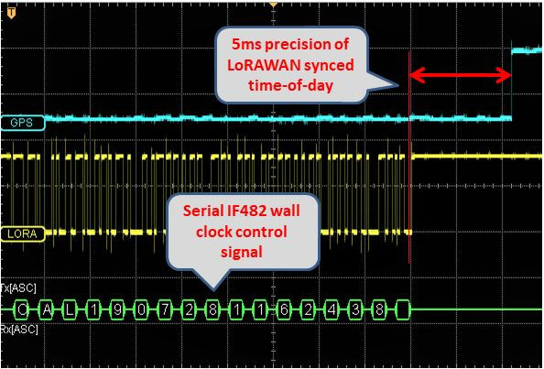
The device assembled containing the components ESP 8266, RFM 95 and a GPS module was priced at approximately ₹ 2,000. The cost observed and compared with other passenger counting devices available in the market is the lowest and once installed this device is negligible and will only require maintenance once a year rather compared to its other counterparts.
The accuracy obtained via this device is on the higher side (95-99%) which in turn is one of the better passenger counter devices available.

Adding up the cost of each device that is placed in all the shuttle cabs around the VIT Vellore campus ensures the whole shuttle cab passenger counting project to ₹ 30,000.

CONCLUSION
Passenger counting can be very useful for the management, scheduling and planning of the public transport, since it enables to set the transport service according to the observed demand, in order to improve the level of service provided to the users.
The different types of available APC systems on the market have been shortly described; the applications show that the use of technologies to detect the location of the vehicle (AVL) is nowadays consolidated and evidently necessary to integrate the information coming from the APC systems.
Finally, no technology is better than the other ones in absolute terms: the final system performance depends on the objectives (i.e., the use of the collected data), on the size of the fleet of vehicles to be monitored, on the need of integration with other technologies and programs which are perhaps already activated within the public transport company, on the numerousness and sampling frequency required, on the type of vehicles and on other factors connected to the service to be dealt with.
You could say that LoRa is “You send few data but they will go further”.
This technology has great applications in reading sensors / meters for sending data over long distances.
You could say that the LoRa radios come from the factory with a frequency or band pre-defined in our case 915MHz, There are some radios that allow working in all bands, since the chip can make the change but the RC filters output the antenna are the drawback given that they are fixed values.
Maximum Distance LoRa:
Max 15-20Km suburban / outdoor, 2Km urban, depends on the quality of the Radio, line of sight, walls walls, etc.
Low RX current of 10.3 mA, 200 nA retention log, according to the RFM95 datasheet.

REFERENCES
- A more complete and technological analysis had been published in “Dalla Chiara, Deflorio, Pinna (2010), “Automatic passenger counting and vehicle load monitoring/ Rilievo automatico dei passeggeri e del carico dei veicoli, Ingegneria Ferroviaria, Ingegneria Ferroviaria – Rome, February 2010”, of which this article is a synthesis and updating.
- IBIS (I/O Buffer Information Specification), RS-485, RS-232 o J1708, Firewire, USB, HDMI (High-Definition Multimedia Interface), Light Peak; in some cases, or on some analysers of specific design, also with other interfaces or with additional switch outputs.
- BOYLE D.K. (1998), “Synthesis of Transit Practice 29, Passenger Counting Technologies and Procedures”, Transit Cooperative Research Program, 1998
- PAVLIDIS I., FRITZ B., SYMOSEK P., PAPANIKOLOPOULOS N. P., MORELLAS V., SFARZO R. (1999), “Automatic Passenger Counting in the HOV Lane”, Minnesota Department of Transportation, 1999.
- KIMPEL T.J., STRATHMAN J.G., GRIFFIN D., CALLAS S., GERHART R.L. (2003), “Automatic Passenger Counter Evaluation: Implications for National Transit Database Reporting”, presented at Transportation Research Board Annual Meeting 2003, Transportation Research Record.
- TCRP (2003), “Uses of Archived AVL-APC Data to Improve Transit Performance and Management: Review and Potential”, Document 23 – Project H-28, Final Report prepared for: “Transit Cooperative Research Program”, TRB of the national academies, by FURTH P.G., HEMILY B. J., MULLER T.H.J., STRATHMAN J.G.; June 2003.
- DALLA CHIARA B., DEFLORIO F.P., PINNA I. (2010), “Automatic passenger counting and vehicle load monitoring / Rilievo automatico dei passeggeri e del carico dei veicoli”, Ingegneria Ferroviaria, vol. LXV, ISSN: 0020-0956. N. 2, pp. 101-138, Rome, CIFI Ed., February 2010.
- "ESP8266 Overview". Espressif Systems. Retrieved 2017-10-02.
- Brian Benchoff (August 26, 2014). "New Chip Alert: The ESP8266 WiFi Module (It's $5)". Hackaday. Retrieved 2015-06-24.
- Brian Benchoff (September 6, 2014). "The Current State of ESP8266 Development". Hackaday. Retrieved 2015-06-24.
- "Espressif Announces ESP8285 Wi-Fi Chip for Wearable Devices". Espressif Systems. Mar 9, 2016. Retrieved 2016-07-10.
- . "Espressif ESP8266 Developer Zone Discussion Forum: Does ESP8266 actually have hardware I2C?". Espressif Systems. 2014-10-27. Retrieved 2017-10-02.
- Brian Benchoff (October 25, 2014). "An SDK for the ESP8266 WiFi Chip". Hackaday. Retrieved 2015-06-24.
- Brian Benchoff (October 25, 2014). "An SDK for the ESP8266 WiFi Chip". Hackaday. Retrieved 2015-06-24.
- Paul Sokolovsky. "esp-open-sdk: Free and open (as much as possible) integrated SDK for ESP8266/ESP8285 chips".
- Max Filippov (February 15, 2015). "ESP8266 GCC Toolchain". Retrieved 2015-08-08.
- Kodali, R. K., & Soratkal, S. (2016, December). MQTT based home automation system using ESP8266. In 2016 IEEE Region 10 Humanitarian Technology Conference (R10-HTC) (pp. 1-5). IEEE.
- Kodali, R. K., & Mahesh, K. S. (2016, December). A low cost implementation of MQTT using ESP8266. In 2016 2nd International Conference on Contemporary Computing and Informatics (IC3I) (pp. 404-408). IEEE.
- Thaker, T. (2016, March). ESP8266 based implementation of wireless sensor network with Linux based web-server. In 2016 Symposium on Colossal Data Analysis and Networking (CDAN) (pp. 1-5). IEEE.
- Singh, P., & Saikia, S. (2016, December). Arduino-based smart irrigation using water flow sensor, soil moisture sensor, temperature sensor and ESP8266 WiFi module. In 2016 IEEE Region 10 Humanitarian Technology Conference (R10-HTC) (pp. 1-4). IEEE.
- Saha, S., & Majumdar, A. (2017, March). Data centre temperature monitoring with ESP8266 based Wireless Sensor Network and cloud based dashboard with real time alert system. In 2017 Devices for Integrated Circuit (DevIC) (pp. 307-310). IEEE.
- Barai, S., Biswas, D., & Sau, B. (2017, December). Estimate distance measurement using NodeMCU ESP8266 based on RSSI technique. In 2017 IEEE Conference on Antenna Measurements & Applications (CAMA) (pp. 170-173). IEEE.
- Škraba, A., Koložvari, A., Kofjač, D., Stojanović, R., Stanovov, V., & Semenkin, E. (2016, June). Streaming pulse data to the cloud with bluetooth LE or NODEMCU ESP8266. In 2016 5th Mediterranean Conference on Embedded Computing (MECO) (pp. 428-431). IEEE.
- Patnaik Patnaikuni, D. R. (2017). A Comparative Study of Arduino, Raspberry Pi and ESP8266 as IoT Development Board. International Journal of Advanced Research in Computer Science, 8(5).
- Oliveira, G. M., Costa, D. C., Cavalcanti, R. J., Oliveira, J. P., Silva, D. R., Nogueira, M. B., & Rodrigues, M. C. (2018, April). Comparison between MQTT and WebSocket protocols for Iot applications using ESP8266. In 2018 Workshop on Metrology for Industry 4.0 and IoT (pp. 236-241). IEEE.
- Tonage, S., Yemul, S., Jare, R., & Patki, V. (2018). IoT based home automation system using NodeMCU ESP8266 module. International Journal of Advance Research and Development.
- Habaebi, M. H., & Azizan, N. I. N. B. (2016, July). Harvesting wifi received signal strength indicator (RSSI) for control/automation system in soho indoor environment with esp8266. In 2016 International Conference on Computer and Communication Engineering (ICCCE) (pp. 416-421). IEEE.
- Azmi, N., Sudin, S., Kamarudin, L. M., Zakaria, A., Visvanathan, R., Cheik, G. C., ... & Ahmad, R. B. (2018). Design and development of multi-transceiver Lorafi board consisting LoRa and ESP8266-Wifi communication module. In IOP Conference Series: Materials Science and Engineering (Vol. 318, No. 1, p. 012051). IOP Publishing.
- Rahman, A., & Suryanegara, M. (2017, May). The development of IoT LoRa: A performance evaluation on LoS and Non-LoS environment at 915 MHz ISM frequency. In 2017 International Conference on Signals and Systems (ICSigSys) (pp. 163-167). IEEE.
- Spinsante, S., Ciattaglia, G., Del Campo, A., Perla, D., Pigini, D., Cancellieri, G., & Gambi, E. (2017, September). A LoRa enabled building automation architecture based on MQTT. In 2017 AEIT International Annual Conference (pp. 1-5). IEEE.
- Nagaraju, C., & Jyothi, P. A. (2020). Performance of LoRa Network for IoT Applications. In Advances in Cybernetics, Cognition, and Machine Learning for Communication Technologies (pp. 313-323). Springer, Singapore.
- Mesquita, J., Guimarães, D., Pereira, C., Santos, F., & Almeida, L. (2018, September). Assessing the ESP8266 WiFi module for the Internet of Things. In 2018 IEEE 23rd International Conference on Emerging Technologies and Factory Automation (ETFA) (Vol. 1, pp. 784-791). IEEE.
- James, J. G., & Nair, S. (2017, November). Efficient, real-time tracking of public transport, using LoRaWAN and RF transceivers. In TENCON 2017-2017 IEEE Region 10 Conference (pp. 2258-2261). IEEE.
- Pulpito, M., Fornarelli, P., Pomo, C., Boccadoro, P., & Grieco, L. A. (2018). On fast prototyping LoRaWAN: a cheap and open platform for daily experiments. IET Wireless Sensor Systems, 8(5), 237-245.
- Fornarelli, M. P. P., Pomo, C., Boccadoro, P., & Grieco, L. A. On fast prototyping LoRaWAN: a cheap and open platform for daily experiments.
- Lee, K. P., Kuhl, S. J., Bockholt, H. J., Rogers, B. P., & Reed, D. A. (2018). A Cloud-Based Scientific Gateway for Internet of Things Data Analytics. In Proceedings of the Practice and Experience on Advanced Research Computing (pp. 1-8).
- Rocha, L. A., Barreto, F., & Seman, L. O. (2019). The Internet of Things LoRaWAN Technologies in Academia: A Case Study. In The Internet of Things in the Industrial Sector (pp. 193-219). Springer, Cham.
- García Fernández, D. (2019). Diseño e implementación de actualizaciones Over The Air (OTA) para redes de sensores inalámbricas.
- Sethi, P., Sarangi, S. R. (2017). “Internet of Things: Architectures, Protocols, and Applications”. Hindawi Publishing Corporation. 1-25.
- Kim, D. H., Lim, J. Y., Kim, J. D. (2016). “Low-Power, Long-Range, High-Data Transmission Using Wi-Fi and LoRa”. 6th International Conference on IT Convergence and Security. 1-3.
- Anand, P. (2015). “Towards Evolution of M2M into Internet of Things for Analytics”. IEEE Recent Advances in Intelligent Computational Systems. 388-393.
- Gupta, R., Gupta, R. (2016). “ABC of Internet of Things : Advancements, Benefits, Challenges, Enablers and Facilities of IoT”. Symposium on Colossal Data Analysis and Networking. 1-5.
- Nolan, K. E., Guibne, W., Kelly, M. Y. (2016). “An Evaluation Of Low Power Wide Area Network Technologies For The Internet Of Things”. International Wireless Communications and Mobile Computing Conference. 439-444.
- So, J., Kim, D., Kim, H., Lee, H., Park, S. (2016). “LoRaCloud: LoRa Platform on OpenStack”. 2016 IEEE NetSoft Conference and Workshops. 431-434
- Petäjäjärvi, J., Mikhaylov, K., Hämäläinen, M., Iinatti, J. (2016). “Evaluation of LoRa LPWAN Technology for Remote Health and Wellbeing Monitoring”. 10th Internasional Symposium on Medical Information and Communication. 1-5.
- Högnelid, P., Kalling, T. (2015). “Internet of Things and Business Models”. IEEE 9th International Conference on Standardization and Innovation in Information Technology. 1-7.
- Bardyn, J. P., Melly, T., Seller, O., Somin, N. (2016). “IoT : The Era of LPWAN is starting now”. 42nd European Solid-State Circuits Conference. 25-30.
- Mikhaylov, K., Petäjäjärvi, J., Hänninen, J. (2016) “Analysis of Capacity and Scalability of the LoRa Low Power Wide Area Network Technology”. Europian Wireless. 119-124.
- Aoudia, F. A., Magno, M., Gautier, M., Berder, O., Benini, L. (2016). “A Low Latency and Energy Efficient Communication Architecture for Heterogeneous Long-Short Range Communication”. 2016 Euromicro Conference on Digital System Design. 200-206.
- Nalbandian, S. (2015). “A survey on Internet of Things: applications and challenges”. International Congress on Technology, Communication and Knowledge. 165-169.

 

